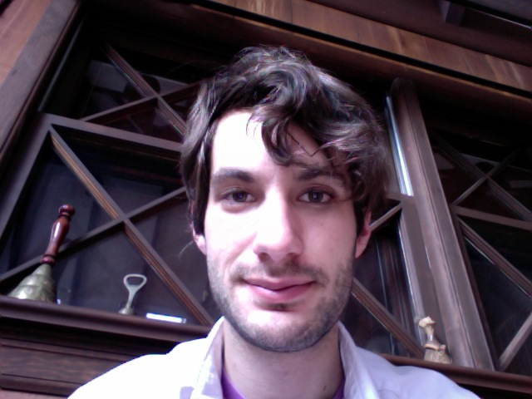
Aaron Henry Krajeski
KRAJESKI@gmail.com • (857) 719-2776

Current Address
44 Rockwood St.
Jamaica Plain, MA 02130

WORK
High School Physics/Mathematics Teacher August 2009 – June 2010
The Suzhou-Singapore International School, Suzhou China
- Taught diploma level physics (standard and higher levels) as well as mathematics (standard level) for the International Baccalaureate program
- Taught middle years program mathematics for grades 9 and 10 in the IB, and applied high school mathematics
- Wrote curriculum for the above courses, streamlined curriculum with middle school teachers
Laboratory Technician and Quality Assurance Specialist May 2008 – August 2009
The College of William and Mary, MINERνA project for the US Department of Energy
- Designed and amended procedures for the construction of the MINERνA neutrino detector
- Tested and calibrated components using photomultiplier tubes and radioactive sources
- Analyzed data from quality assurance tests
- Collaborated with Hampton University and Fermi National Accelerator Laboratory on construction
Secretary/Accountant May 2007 – August 2007
Cobblestone Management, Boston MA
- Organized the finances of this small property management company
- Used professional accounting software
Janitor May 2003 – August 2003
Quality Services, Inc., Boston MA
Web Intern June 2002 – July 2002
National Geographic World (now National Geographic Kids), Washington DC
- Maintained the magazine’s web site using programs such as Flash, Photoshop and Dreamweaver
- Coded in .html and .php
- Corresponded with children who had comments and questions for the magazine

PERSONAL ATTRIBUTES
- STCW basic safety certified (Valid until 2016)
- Computer proficiency: Quickbooks, Microsoft Office, Adobe Flash, Logic Pro, Java and html programming
- Composer of songs and film scores, can tune pianos
- Survival level Arabic, Spanish and Chinese language

HONORS AND ACTIVITIES
Technical Director for WCWM May 2008 – May 2009
- Maintained equipment for the radio station of the College of William & Mary
- Trained new DJs on use of the station
Tutor for Society of Physics Students August 2007 – May 2009
- Tutored underclassmen and non-majors in introductory physics classes
Founder of Song Swap July 2006 –
- Organized and submitted to this song writing collective, designed the website song-swap.com

EDUCATION
B.S. with a major in Physics, minor in Music, May 2009
The College of William and Mary; Williamsburg, VA
GPA: 3.50 The College of William and Mary, Williamsburg, VA
In addition, studied a diverse curriculum, including the following relevant mathematics courses:
- MATH 111-112: Calculus I and II
- MATH 211: Linear Algebra
- MATH 213: Multivariable Calculus for Science and Mathematics
- MATH 302: Ordinary Differential Equations

REFRENCES:
- Nicholas Little, High school principal at the Suzhou Singapore International School, nicholaslittle@ssis-suzhou.net
- Glen Russell, Subject leader for mathematics at the Suzhou Singapore International School, glenfrussel@gmail.com
- Jeffery Nelson, Associate Professor of Physics at the College of William & Mary, (757) 784-3933, jknels@wm.edu
- Sofia Serghi, Professor of Music and Composition at the College of William & Mary, sxserg@wm.edu

